/* A government research lab has concluded that an artificial sweetener commonly used in diet
soda pop will cause death in laboratory mice. A friend of yours is desperate to lose weight
but cannot give up soda pop. Your friend wants to know how much diet soda pop it is possible
to drink without dying as a result.

Write a program to supply the answer. The program has no input but does have defined constants
for the following items: the amount of artificial sweetener needed to kill a mouse, the weight
of the mouse, the starting weight of the dieter, and the desired weight of the dieter.
To ensure the safety of your friend, be sure the program uses the weight at which the dieter
will stop dieting, rather than the dieter’s current weight, to calculate how much soda pop
the dieter can safely drink. You may use any reasonable values for these defined constants.
Assume that diet soda contains 1/10th of 1% artificial sweetener. Use another named constant
for this fraction.

You may want to express the percent as the double value 0.001. (If your program turns out
not to use a defined constant, you may remove that defined constant from your program.) */

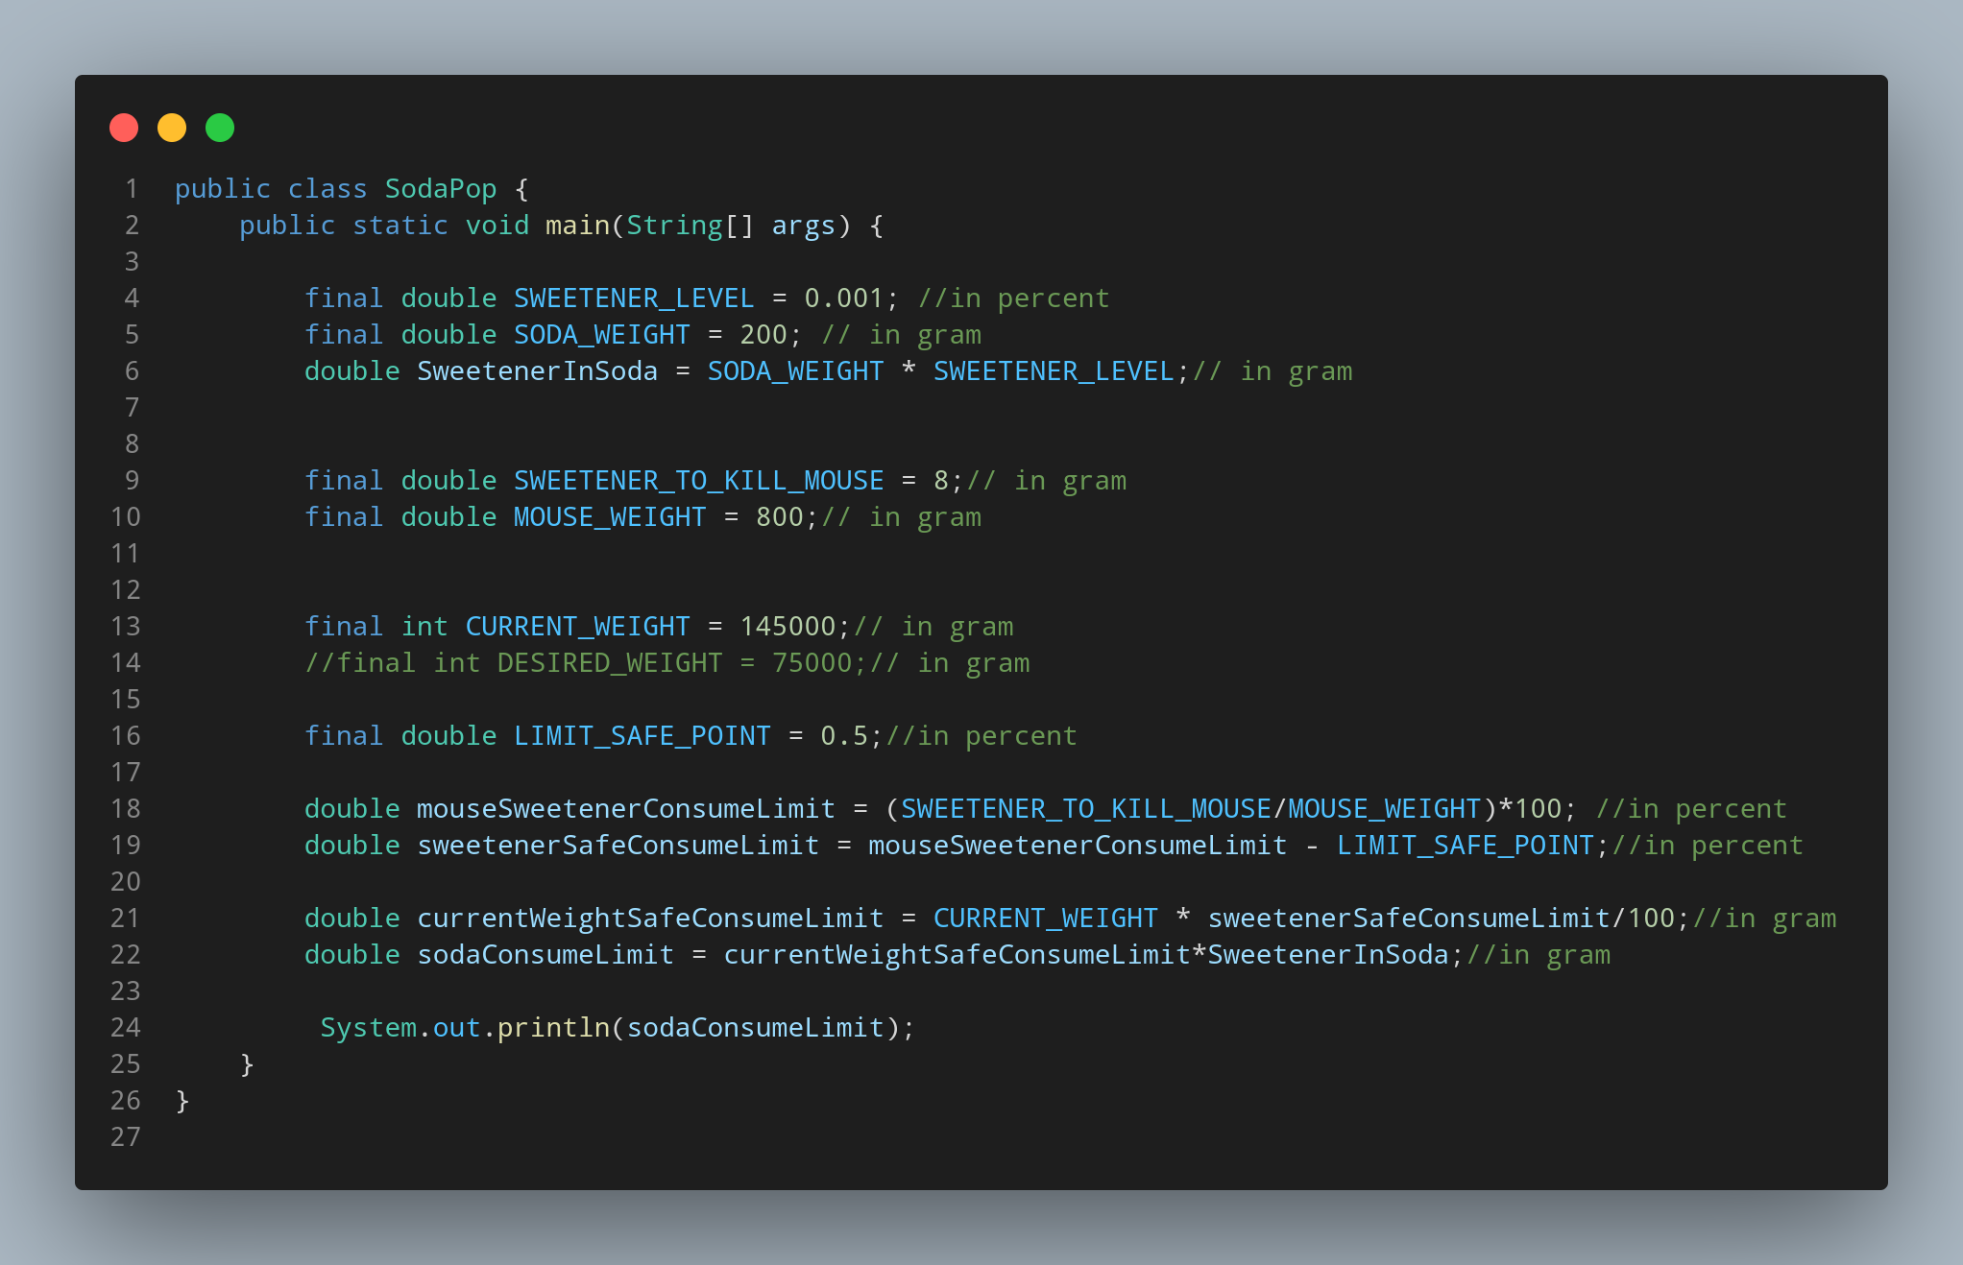

#Doc

File name SodaPop is created so we create a class name SodaPop, inside the class we created a main function.Accorfing to our question lets create some constant, We create SWEETENER_LEVEL, SODA_WEIGHT, SWEETENER_TO_KILL_MOUSE, MOUSE_WEIGHT, CURRENT_WEIGHT, LIMIT_SAFE_POINT as from there we can know what they are used to store the value for. Then we calclate as the instruction given and formula.
Then print all the data.

